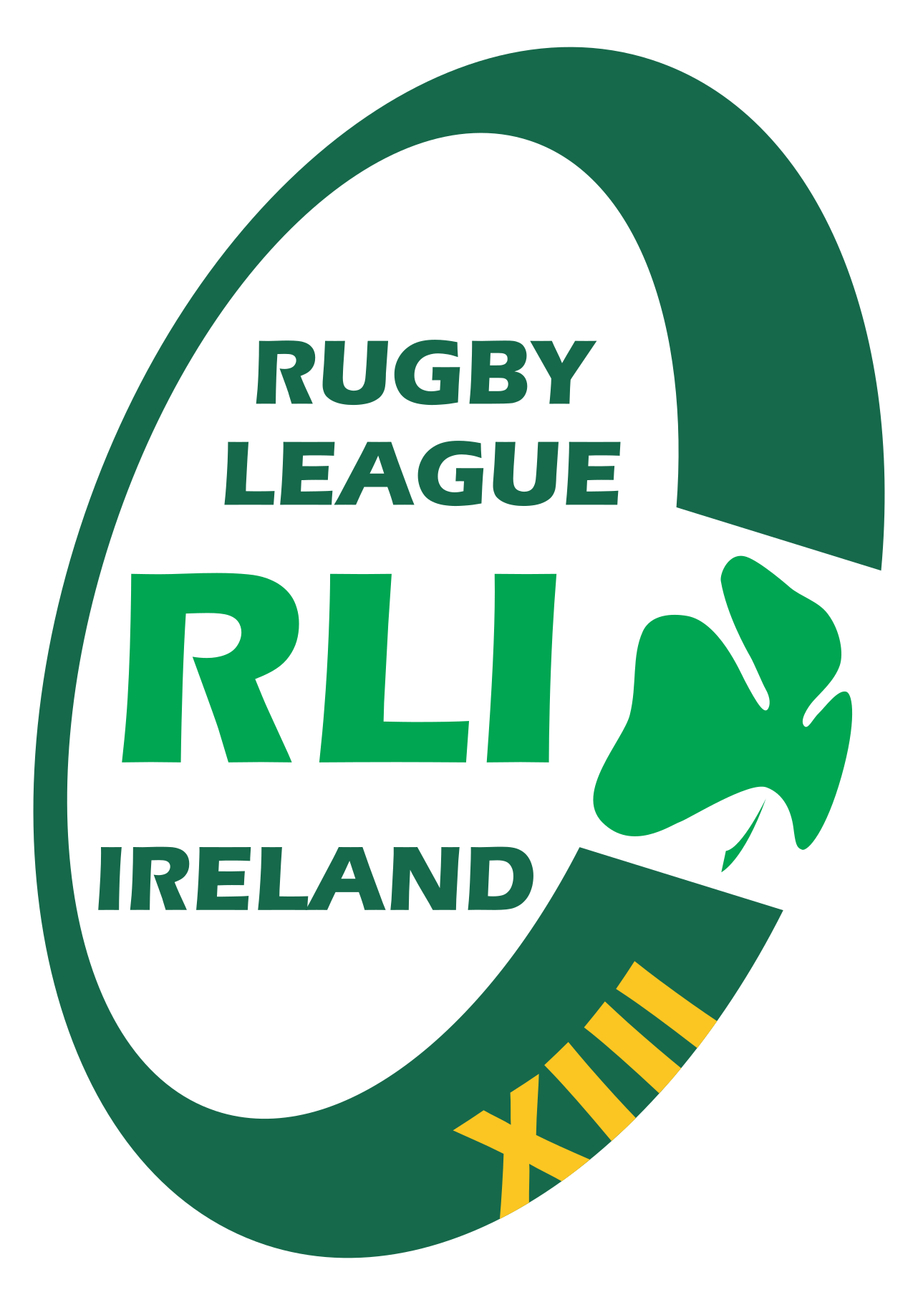

RUGBY LEAGUE
IRELAND

Whistleblowing & Protected Disclosures Policy

1. Introduction
Rugby League Ireland (RLI) is committed to maintaining a culture of honesty, openness, and accountability. Whistleblowing is an essential mechanism for protecting the integrity of the organisation and the sport. This policy sets out how individuals can safely report concerns without fear of retaliation.

2. Purpose
The purpose of this policy is to provide a clear process for reporting wrongdoing, protecting those who report, and ensuring that all disclosures are investigated appropriately.

3. Scope
This policy applies to all board members, employees, players, coaches, volunteers, contractors, match officials, and any individual acting on behalf of RLI.

4. What Can Be Reported?
A protected disclosure may relate to any suspected wrongdoing, including but not limited to:
- Criminal offences or breaches of the law.
- Corruption, bribery, or misuse of organisational funds.
- Match fixing or betting-related misconduct.
- Breaches of safeguarding policies or harm to children or adults at risk.
- Breaches of anti-doping rules.
- Serious breaches of RLI codes of conduct or policies.
- Gross mismanagement or risks to health and safety.
- Retaliation against individuals who report concerns.

5. Who Can Make a Disclosure?
Any individual involved in RLI activities who becomes aware of wrongdoing may make a protected disclosure. Anonymous disclosures will be accepted, although they may limit the investigation process.

6. How to Make a Report
- Reports may be made verbally or in writing.
- Disclosures should be directed to the RLI Integrity Officer or a designated senior official.
- If the concern involves senior leadership, reports may be made directly to Sport Ireland or IRL.
- Urgent safeguarding concerns must be reported immediately to statutory authorities.

7. Protection for Whistleblowers
RLI prohibits retaliation against any individual who makes a disclosure in good faith. No whistleblower will be penalised, dismissed, demoted, or subject to any form of discrimination as a result of reporting concerns.

8. Investigation of Reports
All disclosures will be acknowledged, assessed, and investigated fairly and promptly. Investigations may involve collecting evidence, interviewing relevant individuals, and working with external agencies where necessary.

9. Outcomes & Actions
- Internal disciplinary action.
- Referral to Sport Ireland, International Rugby League, or law enforcement.
- Safeguarding actions if children or adults at risk are involved.
- Policy changes or organisational improvements.

10. Confidentiality
RLI will take all reasonable steps to protect the identity of whistleblowers. Information will be shared only with those who need to know in order to investigate the concern.

11. Malicious or Vexatious Reports
Making a disclosure in bad faith or knowingly providing false information may result in disciplinary action.

12. Review
This policy will be reviewed every two years or sooner if required by legislative or governance changes.

