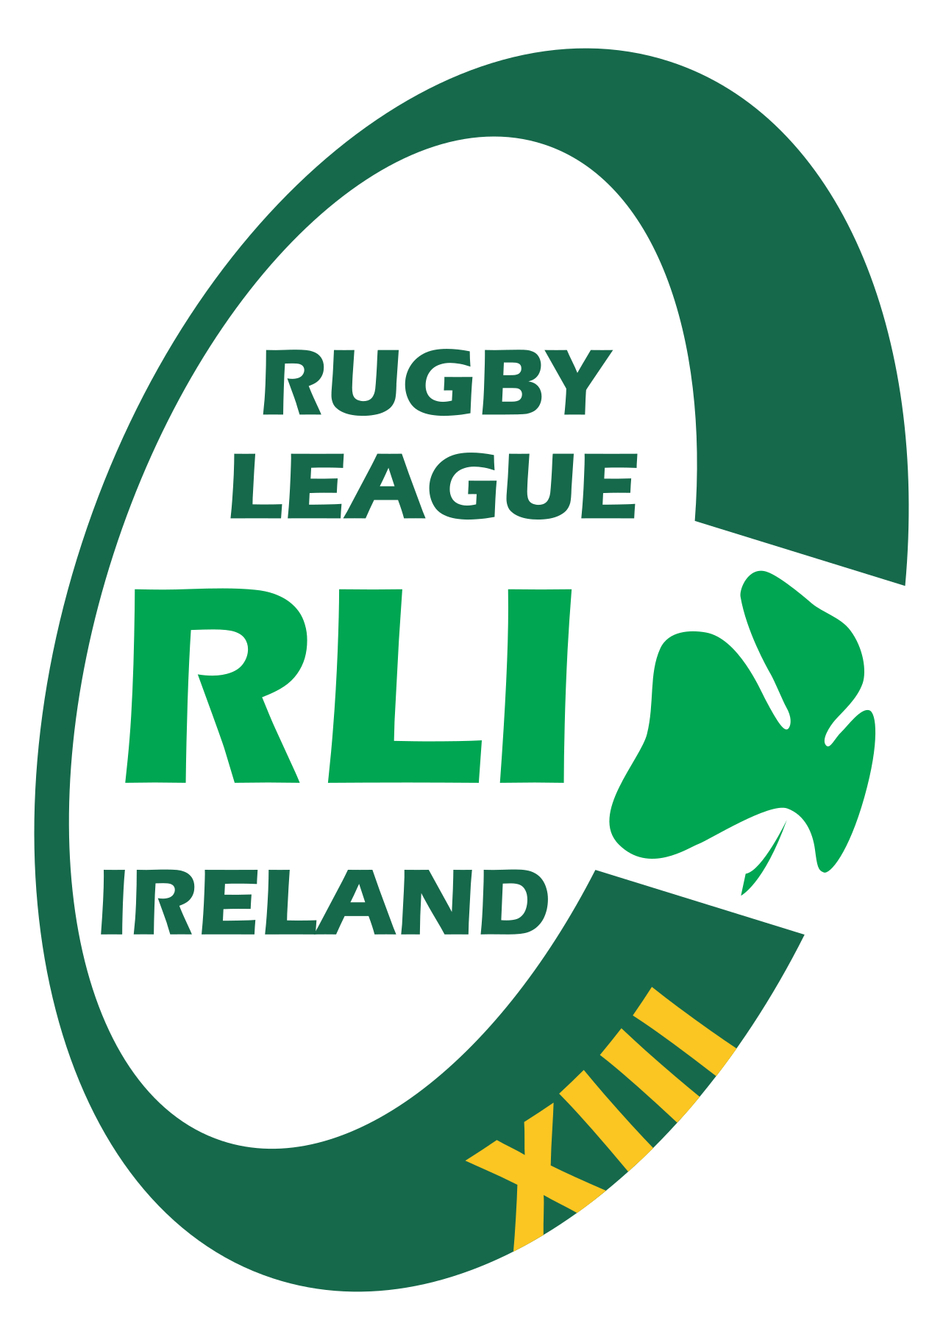

RUGBY LEAGUE
IRELAND

Match Fixing & Betting Integrity Policy

1. Introduction
Rugby League Ireland (RLI) is committed to upholding the integrity of the sport and ensuring all competitions are conducted fairly, honestly, and free from manipulation. Match fixing, improper betting, and the misuse of inside information threaten the core values of rugby league and will not be tolerated.

2. Purpose
The purpose of this policy is to set out clear expectations, rules, and procedures for preventing, identifying, and addressing match fixing and betting-related misconduct within Rugby League Ireland.

3. Scope
This policy applies to all players, coaches, match officials, club staff, volunteers, board members, and anyone engaged in RLI activities or representing the organisation domestically or internationally.

4. Definition of Match Fixing
Match fixing is any action taken to improperly influence the outcome, score, event, or any aspect of a match for personal, financial, or organisational gain. This includes attempts, agreements, or encouragement to influence matches.

5. Prohibited Conduct
The following actions are strictly prohibited and considered breaches of RLI integrity standards:
- Fixing or attempting to fix the outcome or any aspect of a match.
- Improperly influencing referees, players, or team staff.
- Betting on any rugby league competition in which the individual is involved.
- Providing inside information for betting or gambling purposes.
- Failing to report approaches or suspicious activities.
- Using or encouraging others to use confidential or non-public information for betting gains.

6. Duty to Report
- Any approach, incentive, or request to influence a match must be reported immediately.
- Any suspicious behaviour or suspected corruption must be reported to RLI.
- Reports must be made to the Integrity Officer or a senior RLI official as soon as possible.

7. Investigation Process
RLI will investigate all allegations of match fixing or betting misconduct. Investigations may involve interviews, evidence gathering, review of betting activity, and collaboration with Sport Ireland, IRL, or law enforcement if required.

8. Sanctions
- Suspension or expulsion from RLI activities.
- Removal from squads, coaching roles, or officiating appointments.
- Referral to International Rugby League (IRL) or Sport Ireland.
- Possible criminal investigation under Irish law.

9. Education & Awareness
RLI will provide education on integrity, betting risks, and match fixing for players, coaches, referees, and officials. Participation in integrity education sessions may be mandatory.

10. Review
This policy will be reviewed every two years or sooner if required to comply with IRL or Sport Ireland integrity standards.

