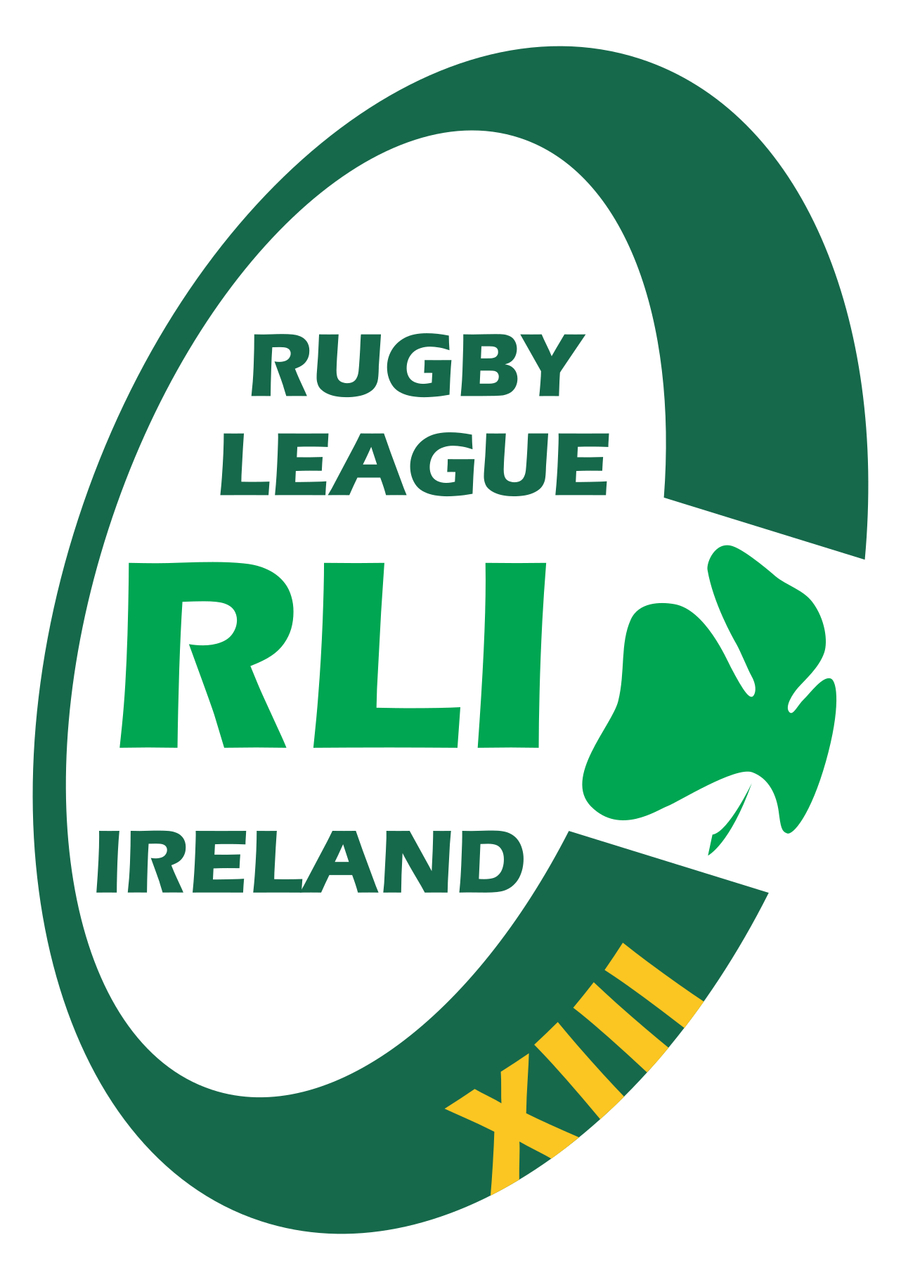

Rugby League Ireland

Conflict of Interest Policy

1. Introduction
Rugby League Ireland (RLI) is committed to maintaining the highest standards of integrity, transparency, and accountability. All officers, board members, volunteers, coaches, match officials, and individuals acting on behalf of RLI must avoid situations where personal interests conflict, or could be perceived to conflict, with the best interests of the organisation.

2. Purpose
The purpose of this policy is to ensure that RLI decisions are fair, objective, and free from improper influence, and that conflicts of interest are identified, declared, and appropriately managed.

3. Definition of a Conflict of Interest
A conflict of interest arises when an individual’s personal, financial, or other interests could compromise or influence their judgment or actions within RLI. Conflicts may be actual, potential, or perceived.

4. Examples of Conflicts of Interest
Examples include (but are not limited to):
- Personal or family financial interests in suppliers or contracts considered by RLI.
- Serving on the board of another organisation with competing interests.
- Using RLI resources for personal gain.
- Participating in decisions where a close family member stands to benefit.

5. Duty to Disclose
- Declare any conflict of interest as soon as it arises.
- Submit an annual declaration of interests.
- Update their declaration whenever circumstances change.

6. Management of Conflicts
- Removing the individual from related decision-making processes.
- Requiring abstention from voting or discussions.
- Documenting the conflict and actions taken to address it.

7. Record Keeping
RLI will maintain a secure Register of Interests documenting declarations. This register will be reviewed annually by the Board or a designated Governance Officer.

8. Breaches of the Policy
Failure to disclose a conflict of interest may result in disciplinary action, including removal from roles or referral to Sport Ireland, depending on severity.

9. Review
This policy will be reviewed every two years or sooner if required due to legislative or governance changes.
Rugby League Ireland - 2026

