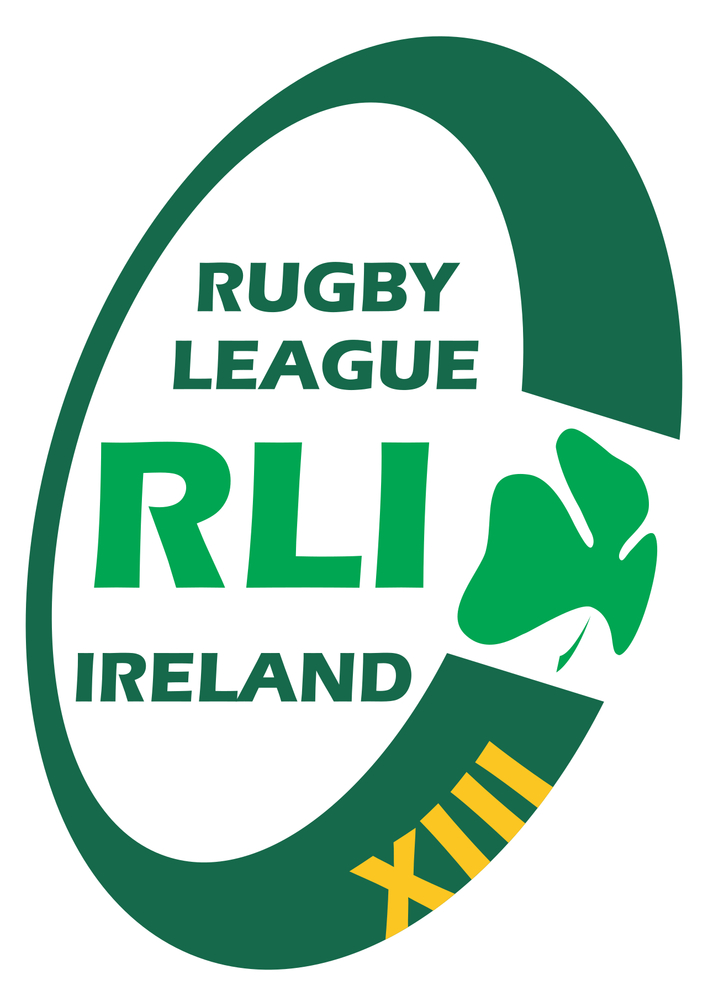

RUGBY LEAGUE
IRELAND

Board Code of Conduct

1. Purpose
This Board Code of Conduct outlines the standards of behaviour expected of all members of the Board of Rugby League Ireland (RLI). Board members must act with integrity, transparency, and professionalism to uphold the reputation and effective governance of RLI.

2. Scope
This Code applies to all elected, appointed, or co-opted members of the RLI Board and any individuals attending Board meetings in an official capacity.

3. Core Principles
- Integrity – acting honestly and ethically at all times.
- Accountability – taking responsibility for decisions and actions.
- Transparency – supporting open communication and good governance.
- Confidentiality – protecting sensitive information appropriately.
- Respect – treating all individuals with fairness and professionalism.
- Objectivity – making decisions free from personal bias or conflict.
- Loyalty – supporting the collective decisions of the Board.

4. Duties and Responsibilities
- Act in the best interests of Rugby League Ireland at all times.
- Prepare for and attend all Board meetings where possible.
- Participate constructively in discussions and decision-making.
- Uphold and monitor compliance with RLI policies and procedures.
- Ensure financial oversight and responsible resource management.
- Promote good governance and support RLI’s long-term strategic direction.
- Represent RLI positively in all public and private interactions.

5. Conflicts of Interest
Board members must declare any actual, potential, or perceived conflicts of interest at the earliest opportunity, in accordance with the RLI Conflict of Interest Policy. Conflicted individuals must remove themselves from related discussions and decisions.

6. Confidentiality
Board members will not disclose confidential information obtained through their role unless authorised or legally required. This includes financial data, personal information, strategic planning documents, and sensitive organisational matters.

7. Conduct at Board Meetings
- Treat all Board members, staff, volunteers, and stakeholders with respect.
- Allow others to contribute without interruption.
- Engage in constructive debate and avoid personal criticism.
- Support the Chair in maintaining order and effective meeting procedure.
- Accept and uphold majority decisions once made.

8. Use of RLI Resources
Board members must ensure that RLI resources, including finances, equipment, and intellectual property, are used only for legitimate organisational purposes and never for personal gain.

9. Integrity, Legal and Ethical Compliance
- Comply with all applicable Irish laws, Sport Ireland requirements, and IRL policies.
- Promote ethical behaviour and report any suspected misconduct.
- Uphold anti-doping, safeguarding, and integrity standards across the organisation.

10. Breaches of the Code
Any breach of this Code may result in disciplinary action, including removal from the Board, in accordance with the RLI Constitution and relevant policies. Serious breaches may be referred to Sport Ireland, IRL, or statutory authorities.

11. Acknowledgement and Commitment
All Board members must sign an annual declaration confirming that they have read, understand, and agree to abide by this Board Code of Conduct.

