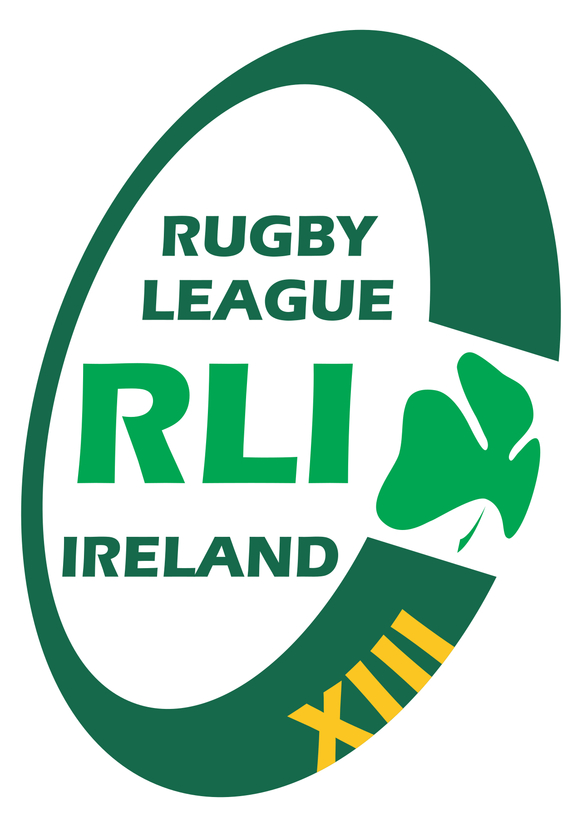

RUGBY LEAGUE
IRELAND

Anti-Corruption & Integrity Statement

1. Introduction
Rugby League Ireland (RLI) is committed to the highest standards of integrity, transparency, and ethical conduct. Corruption in any form undermines the values of the sport and erodes trust among participants, supporters, and partners. This Anti-Corruption Statement outlines RLI’s zero-tolerance approach to corruption, bribery, manipulation, and abuse of position.

2. Purpose
The purpose of this statement is to clearly communicate RLI’s commitment to preventing corruption and ensuring that all individuals associated with the organisation act with honesty, fairness, and accountability.

3. Scope
This statement applies to all individuals involved with RLI, including board members, employees, volunteers, coaches, match officials, players, contractors, and representatives at any level.

4. Prohibited Conduct
- Offering, giving, receiving, or requesting bribes or improper payments.
- Manipulating matches, competitions, or appointments for personal gain.
- Using insider information for financial benefit or to influence others.
- Undisclosed conflicts of interest affecting decisions or responsibilities.
- Misuse or misappropriation of RLI funds or property.
- Any conduct that compromises the integrity of Rugby League Ireland or the sport.

5. Responsibilities of Individuals
- Act honestly and transparently in all organisational activities.
- Declare any conflicts of interest promptly.
- Refuse any gifts, benefits, or incentives that could influence decision-making.
- Report any suspected corruption or unethical behaviour immediately.
- Cooperate fully with investigations or integrity reviews.

6. Reporting Concerns
Any suspected corruption, manipulation, bribery, or unethical behaviour must be reported immediately to the RLI Integrity Officer. Reports may also be made under the Whistleblowing & Protected Disclosures Policy. Serious concerns may be referred to Sport Ireland, International Rugby League (IRL), or statutory authorities.

7. Investigations
RLI will investigate all allegations of corruption promptly and fairly. Investigations may involve reviewing evidence, interviewing relevant individuals, and cooperating with external bodies where necessary.

8. Consequences of Misconduct
- Disciplinary action including suspension or removal from roles.
- Termination of employment or volunteer status.
- Referral to Sport Ireland or IRL for further sanctions.
- Referral to An Garda Síochána or other authorities for criminal investigation.

9. RLI Commitment to Integrity
RLI is committed to promoting a culture of fairness, accountability, and transparency. Everyone involved with Rugby League Ireland shares responsibility for upholding these values and ensuring that the sport remains free from corruption.

10. Review
This statement will be reviewed every two years or sooner if required by updates in governance or legislation.

