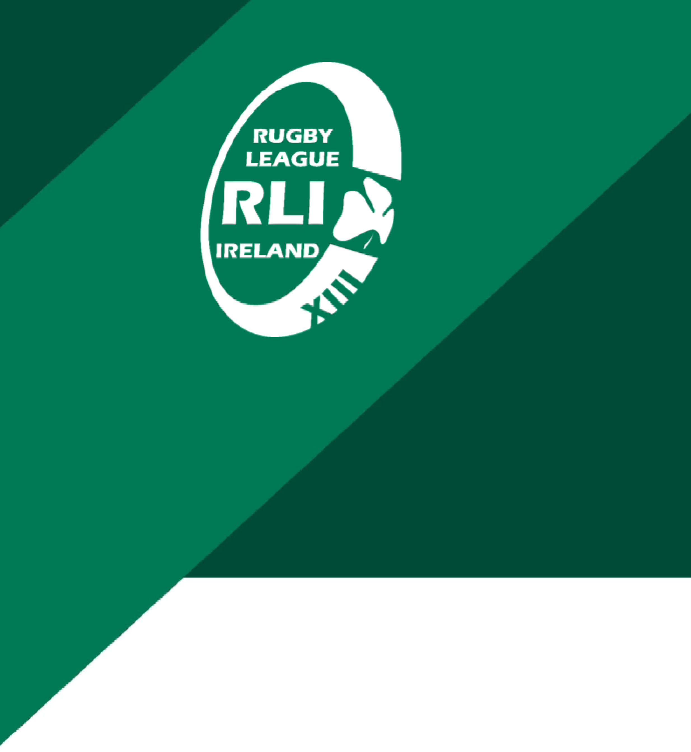

Rugby League Ireland – Cookie Policy

Rugby League Ireland – Cookie Policy
This Cookie Policy explains how Rugby League Ireland ("RLI") uses cookies and similar technologies on its website.
What Are Cookies
Cookies are small text files that are placed on your device when you visit a website. They are widely used to ensure websites function properly and to provide information to site owners.
How We Use Cookies
RLI uses cookies to ensure the effective operation of its website, to analyse website usage, and to improve user experience. Cookies may collect information such as browser type, pages visited, and time spent on the site.
Types of Cookies Used
Essential cookies are required for the website to function properly. Analytical cookies help us understand how visitors interact with the website. Functional cookies remember user preferences where applicable.
Managing Cookies
You can control and manage cookies through your browser settings. Most browsers allow you to refuse or delete cookies. Please note that disabling cookies may affect website functionality.
Third-Party Cookies
Some cookies may be placed by third-party services used on the website, such as analytics or embedded content. These third parties are responsible for their own cookie practices.
Changes to This Policy
This Cookie Policy may be updated from time to time to reflect changes in technology or legal requirements.
Contact
If you have any questions about this Cookie Policy, please contact Rugby League Ireland at: [insert contact email].

