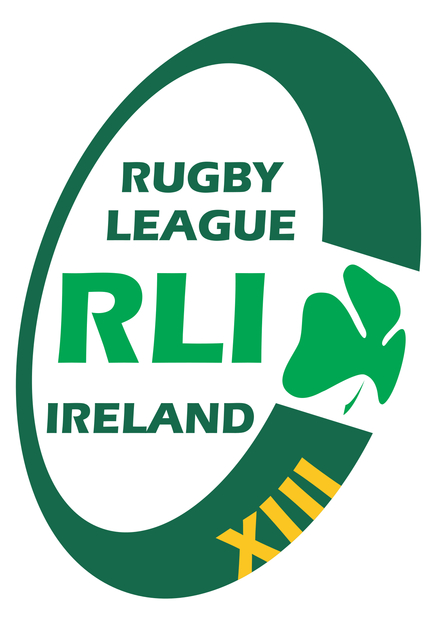

RUGBY LEAGUE
IRELAND

Equality & Inclusion Policy

1. Purpose
Rugby League Ireland (RLI) is committed to promoting equality, inclusion, and respect for all individuals involved in rugby league. This policy outlines RLI’s commitment to providing a safe, welcoming, and accessible environment where everyone can participate regardless of background, identity, or personal circumstances.

2. Scope
This policy applies to all RLI board members, staff, volunteers, players, coaches, match officials, parents, supporters, and affiliated clubs.

3. Policy Statement
RLI will not tolerate discrimination, harassment, or exclusion on the grounds of gender, marital status, family status, age, disability, sexual orientation, race, nationality, ethnic origin, religious belief, or membership of the Traveller community, in line with Irish equality legislation.

4. Core Principles
- Fair and equal treatment for all participants and stakeholders.
- A commitment to creating inclusive environments across all RLI activities.
- Respect for individual differences and cultural diversity.
- Accessibility and opportunities for participation for all groups.
- Zero tolerance for discriminatory or exclusionary behaviour.

5. Responsibilities
- The RLI Board will ensure this policy is adopted, implemented, and reviewed.
- Coaches and volunteers must promote inclusive practice at all times.
- Clubs must create welcoming and safe environments for all members.
- Participants must treat each other with respect and fairness.
- Incidents of discrimination must be reported promptly through appropriate channels.

6. Inclusive Participation
RLI will work to ensure that all individuals have equal opportunities to access rugby league, including playing, coaching, officiating, volunteering, and leadership roles. RLI supports participation across all ages, genders, abilities, and backgrounds.

7. Anti-Discrimination Commitment
- RLI will take all allegations of discrimination seriously.
- Investigations will be handled fairly, confidentially, and in line with RLI policies.
- Appropriate disciplinary action will be taken where discrimination is proven.

8. Accessibility
RLI will strive to improve accessibility in facilities, communications, and programmes wherever possible, and will support clubs in adapting practices to include individuals with disabilities and additional needs.

9. Reporting Concerns
Any individual who experiences or witnesses discrimination, harassment, or exclusion should report the concern through RLI’s Complaints Policy or Whistleblowing & Protected Disclosures Policy. All concerns will be addressed promptly and sensitively.

10. Education & Awareness
RLI will promote awareness of equality and inclusion through training, communication, and providing resources to clubs, volunteers, and participants.

11. Monitoring & Review
The RLI Board will review this policy every two years, or sooner if legislative or organisational changes require. Clubs may be asked to demonstrate how they are meeting the expectations set out in this policy.

