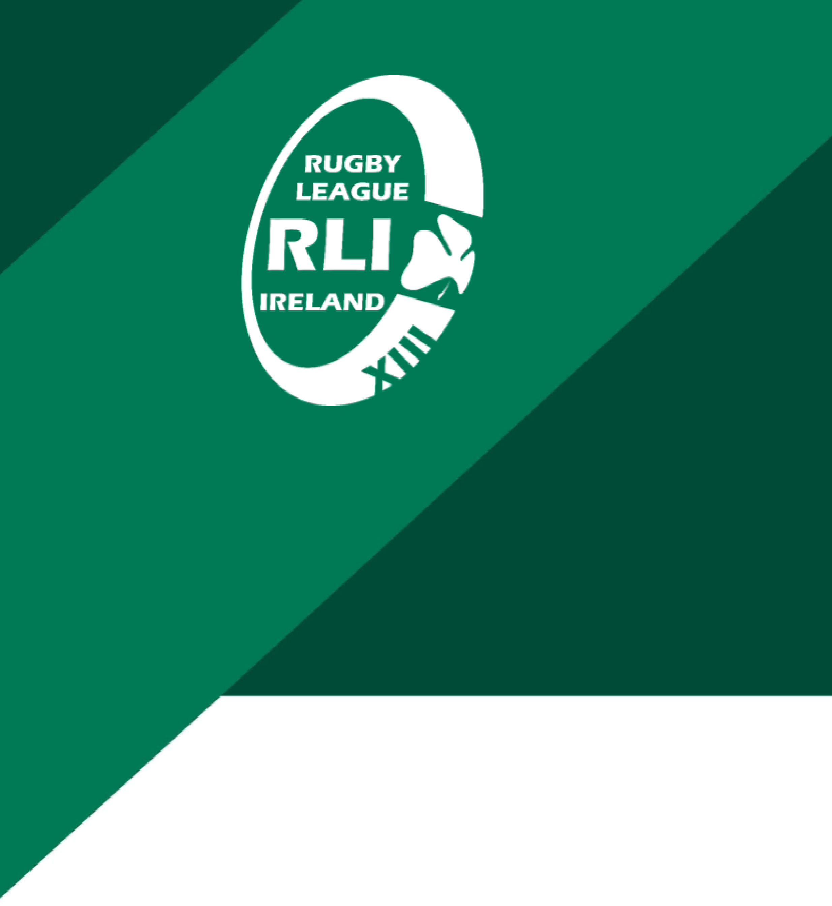

Rugby League Ireland – Privacy Statement

Rugby League Ireland – Privacy Statement
Rugby League Ireland ("RLI") is committed to protecting the privacy and personal data of its members, players, volunteers, officials, staff, and website users. This Privacy Statement explains how we collect, use, store, and protect personal data in accordance with the General Data Protection Regulation (GDPR) and Irish data protection law.
Who We Are
Rugby League Ireland is the National Governing Body for Rugby League in Ireland. For the purposes of data protection law, Rugby League Ireland acts as a Data Controller in respect of the personal data it processes.
What Personal Data We Collect
RLI may collect and process personal data including names, contact details, dates of birth, membership and registration information, competition participation details, safeguarding information, and, where necessary, health-related information such as injury or concussion data.
How We Use Personal Data
Personal data is processed for the purposes of administering rugby league activities, managing memberships and competitions, complying with safeguarding and legal obligations, communicating with members and stakeholders, and promoting the development of rugby league.
Lawful Basis for Processing
RLI processes personal data on the basis of contractual necessity, legal obligation, legitimate interests, and, where appropriate, consent. Special category data is processed only where necessary and with appropriate safeguards in place.
Sharing of Personal Data
Personal data may be shared with trusted third parties such as competition organisers, safeguarding authorities, service providers, or regulatory bodies where required. All third-party processors are subject to appropriate contractual safeguards.
Data Retention
Personal data is retained only for as long as necessary for the purposes for which it was collected and in accordance with RLI’s Data Retention practices.
Your Data Protection Rights
Individuals have the right to access, rectify, erase, restrict, or object to the processing of their personal data, and the right to lodge a complaint with the Data Protection Commission.
Data Security
RLI implements appropriate technical and organisational measures to protect personal data against unauthorised access, loss, or misuse.
Contact
Data protection queries or requests may be directed to Rugby League Ireland at: [insert data protection contact email].

